Example: ALV Reporting using classes – ABORT Error - Field Catalog Not Found
REPORT ZALVREP14.
data v_empno type y930emp-empno.
SELECT-OPTIONS so_empno for v_empno DEFAULT 1 to 100.
data cust_cont type ref to cl_gui_custom_container.
data o_grid type ref to cl_gui_alv_grid.
types : begin of ty_emp.
include type y930emp.
types end of ty_emp.
data t_emp type table of ty_emp.
START-OF-SELECTION.
call screen 100.
MODULE status_0100 OUTPUT.
SET PF-STATUS 'ABC'.
* SET TITLEBAR 'xxx'.
* link custom control with custom container
CREATE OBJECT cust_cont
EXPORTING
container_name = 'CSTCTRL'. "name of custom control
* link alv grid with custom container
CREATE OBJECT o_grid
EXPORTING
i_parent = cust_cont.
* get the employee data
select * from y930emp into table t_emp where empno in so_empno.
if sy-subrc eq 0.
CALL METHOD o_grid->set_table_for_first_display
* EXPORTING
* i_structure_name =
CHANGING
it_outtab = t_emp.
else.
message 'No emp data' type 'I'.
endif.
ENDMODULE.
MODULE user_command_0100 INPUT.
case sy-ucomm.
when 'BACK'.
leave PROGRAM.
endcase.
ENDMODULE.
Flow logic:
PROCESS BEFORE OUTPUT.
MODULE STATUS_0100.
*
PROCESS AFTER INPUT.
MODULE USER_COMMAND_0100.
Screen Layout:
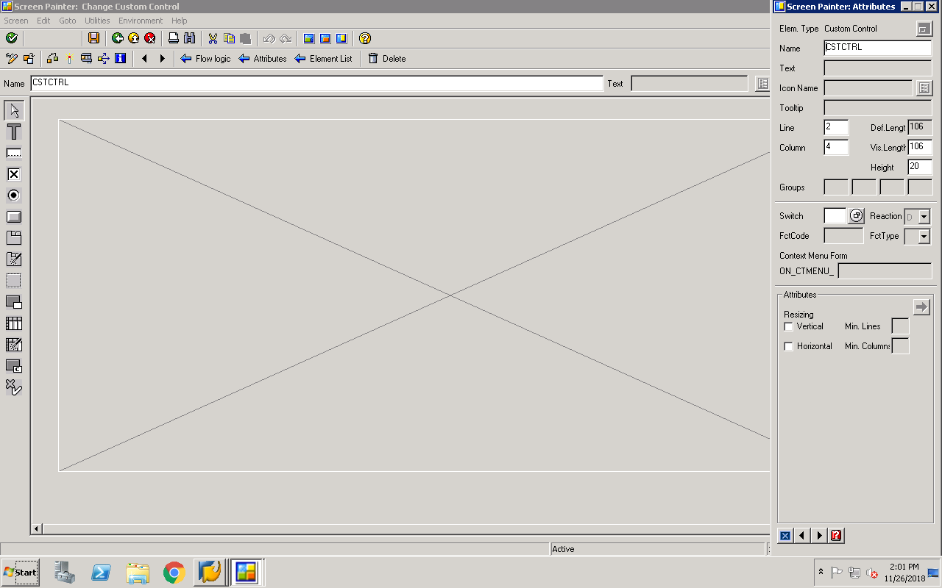
Example: ALV Reporting using classes – Field Catalog info.specified referring to dictionary structure
REPORT ZALVREP15.
data v_empno type y930emp-empno.
SELECT-OPTIONS so_empno for v_empno DEFAULT 1 to 100.
data cust_cont type ref to cl_gui_custom_container.
data o_grid type ref to cl_gui_alv_grid.
types : begin of ty_emp.
include type y930emp.
types end of ty_emp.
data t_emp type table of ty_emp.
START-OF-SELECTION.
call screen 100.
MODULE status_0100 OUTPUT.
SET PF-STATUS 'ABC'.
* SET TITLEBAR 'xxx'.
* link custom control with custom container
CREATE OBJECT cust_cont
EXPORTING
container_name = 'CSTCTRL'. "name of custom control
* link alv grid with custom container
CREATE OBJECT o_grid
EXPORTING
i_parent = cust_cont.
* get the employee data
select * from y930emp into table t_emp where empno in so_empno.
if sy-subrc eq 0.
CALL METHOD o_grid->set_table_for_first_display
EXPORTING
i_structure_name = 'Y930EMP'
CHANGING
it_outtab = t_emp.
else.
message 'No emp data' type 'I'.
endif.
ENDMODULE.
MODULE user_command_0100 INPUT.
case sy-ucomm.
when 'BACK'.
leave PROGRAM.
endcase.
ENDMODULE.
Flow Logic:
PROCESS BEFORE OUTPUT.
MODULE STATUS_0100.
*
PROCESS AFTER INPUT.
MODULE USER_COMMAND_0100.
Screen Layout:
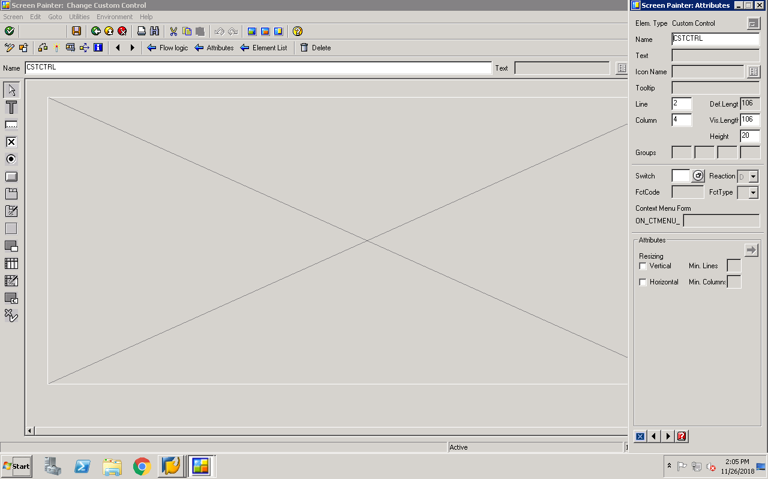

Dictionary structure: y930emp
